Week 1
Subject: Is cancer inevitable or preventable?

In this educational campaign, aptly called, Cancer: Be aware, not afraid, we want to encourage you to think about cancer as a disease that is not only beatable but even preventable.
We’re going to focus on three types of cancer: breast, skin, and colon cancer. All of them are potentially life threatening. But all of them can be treated with a high degree of success in the early stages of the disease. You may even be able to prevent these cancers from developing in your body in the first place!
The key is awareness and action. Medical researchers don’t yet understand what triggers cancer cells to start proliferating and spreading. But you may be surprised at how much we’ve learned about how to keep cancers from ever developing. And there are effective screening tests available that can catch cancers early, making them much easier to treat.
Look for upcoming emails, articles, and flyers with information about how to prevent and check for cancer.

[Disclaimer]
The information and materials included in MetLife’s Health and Wellness Information Library, including all toolkits, modules, template communications, text, charts, graphics and other materials, (collectively, the “Content”) are intended to provide general guidance on health and wellness matters and are not, and should not be relied on as, medical advice. While the Content is based on resources that MetLife believes to be well-documented, MetLife is not responsible for the accuracy of the Content, and you rely on the Content at your own risk. Each person’s condition and health circumstances are unique, and therefore the Content may not apply to you. The Content is not a substitute for professional medical advice. You should always consult your licensed health care professional for the diagnosis and treatment of any medical condition and before starting or changing your health regimen, including seeking advice regarding what drugs, diet, exercise routines, physical activities or procedures are appropriate for your particular condition and circumstances.
© 2017 METLIFE, INC.

Week 2

Subject: Breast cancer: from self-exam to mammogram
For years, women were urged to do breast self-exams every month. As other tests, like mammograms, have given doctors the ability to detect cancer masses before they are too small to be felt, self-exams are not considered as vital. However, it’s good to know your own body, so you can be aware of worrisome changes.
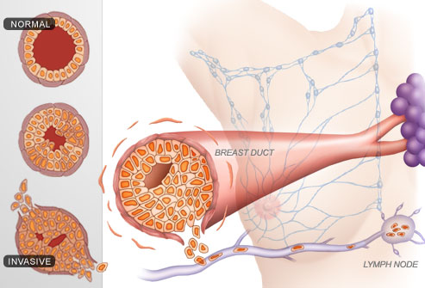
You should check your breasts once a month, three to five days after your menstrual period ends. If you do find a lump, don’t panic.¹ As high as eighty percent of breast lumps aren’t cancerous; they turn out to be harmless cysts or tissue changes related to your menstrual cycle.¹ But you should make an appointment with your healthcare provider if you find something unusual.
Figure from WebMD 1
Recommendations for starting regular mammogram screenings (usually once a year) vary in different parts of the world. For example, the US Preventive Service Task Force recommends mammograms every 2 years from ages 50-74 for women without risk.² Find out what your healthcare provider recommends. Each woman’s situation is different, and your doctor may want you to have a mammogram earlier.
If you’re diagnosed with breast cancer, the next step will be “staging” the cancer.² That’s the process of figuring out how big the tumor is and how much of your body it affects.² For example, has it spread beyond the breast tissue to nearby lymph nodes?
This is all part of determining whether more tests are needed and what your treatment plan should be. Remember that the American Cancer Society says 100% of women with stage 1 breast cancer live at least 5 years, and many women in this group remain cancer-free. Which is another reminder that vigilance and early detection are incredibly important in beating breast cancer.

[Disclaimer]
The information and materials included in MetLife’s Health and Wellness Information Library, including all toolkits, modules, template communications, text, charts, graphics and other materials, (collectively, the “Content”) are intended to provide general guidance on health and wellness matters and are not, and should not be relied on as, medical advice. While the Content is based on resources that MetLife believes to be well-documented, MetLife is not responsible for the accuracy of the Content, and you rely on the Content at your own risk. Each person’s condition and health circumstances are unique, and therefore the Content may not apply to you. The Content is not a substitute for professional medical advice. You should always consult your licensed health care professional for the diagnosis and treatment of any medical condition and before starting or changing your health regimen, including seeking advice regarding what drugs, diet, exercise routines, physical activities or procedures are appropriate for your particular condition and circumstances.
© 2017 METLIFE, INC.

Week 3

Subject: UV radiation: what you can’t see can hurt you
Life on earth wouldn’t survive without the sun. But, as humans, we can die if we have too much exposure to the sun. In fact, skin cancer is the most common type of cancer. It usually forms in skin that has been exposed to sunlight (although it can occur anywhere on the body, and sun isn’t the only cause of skin cancer).
Skin has several layers. Skin cancer begins in the epidermis (the outer layer of the skin).¹ Sunlight causes damage through ultraviolet radiation or UV rays.¹ Your exposure to UV rays may vary depending on where you’re located.² For example, Australia gets about 15 percent more UV rays because of the tilt of the earth’s axis.
Research shows that patients, not doctors, detect most skin cancers. Here are some suggestions for how to check your skin and what to look for:
- Check the skin on all surfaces of your body, including your back, scalp, underarms, genitalia, palms, soles of your feet, and areas between your toes and fingers.
- Watch for the appearance of new moles or other growths on your skin.
- Check for changes in the appearance of an old growth on the skin or scar (especially a burn scar).
- Notice any skin areas that have a different color from any other areas on your skin, and track whether these patches darken or change color.
- Watch for a sore that doesn’t heal (and may bleed or form a crust).
- Check your nails for a dark band, and especially if the band begins to spread.
Talk with your healthcare provider if you see any changes on your skin that do not go away within one month.³ It can be a benign tumor, a malignant tumor, or a pre-malignant tumor (a tumor that is benign but has the potential to become cancerous, if not treated.)³ To evaluate a skin lesion, a doctor will first examine it. If suspicious for cancer, the doctor may remove all or a partial piece of the skin for lab testing (called a skin biopsy.)³ A biopsy can determine whether you have skin cancer and, if so, what type of skin cancer you have.³ If lab testing determines you have skin cancer, you may have additional tests to determine the extent (stage) of the cancer.³ Treatment is with surgical removal if the tumor is localized.³ Surgical removal as well as radiation and chemotherapy/immunotherapy (drugs) are used for more aggressive tumors.³
Basal and squamous cell carcinoma, known as non-melanoma skin cancers, are the most common types of skin cancer – for example, they make up more than 98% of all cases of skin cancer in the United States. They can be treated and rarely result in death— although the two types of nonmelanoma skin cancers are the most common of all cancers, they account for less than 0.1% of patient deaths caused by cancer in the United States. Basal cell carcinoma most commonly appears as a shiny lesion that is not very aggressive. Squamous cell carcinoma most commonly appears as a hard lump with a scaly top but can also form an ulcer – it is more aggressive than basal cell carcinomas.

Figure 1 shows you the “ABCDEs” of identifying a particularly dangerous type of skin cancer called melanoma, which most commonly appears as a mole or nodule. It is much less common than non-melanoma skin cancers but it is more likely to result in death due to its aggressiveness in spreading. The next time you see your healthcare provider, ask him or her to explain how to check for skin cancer at home.

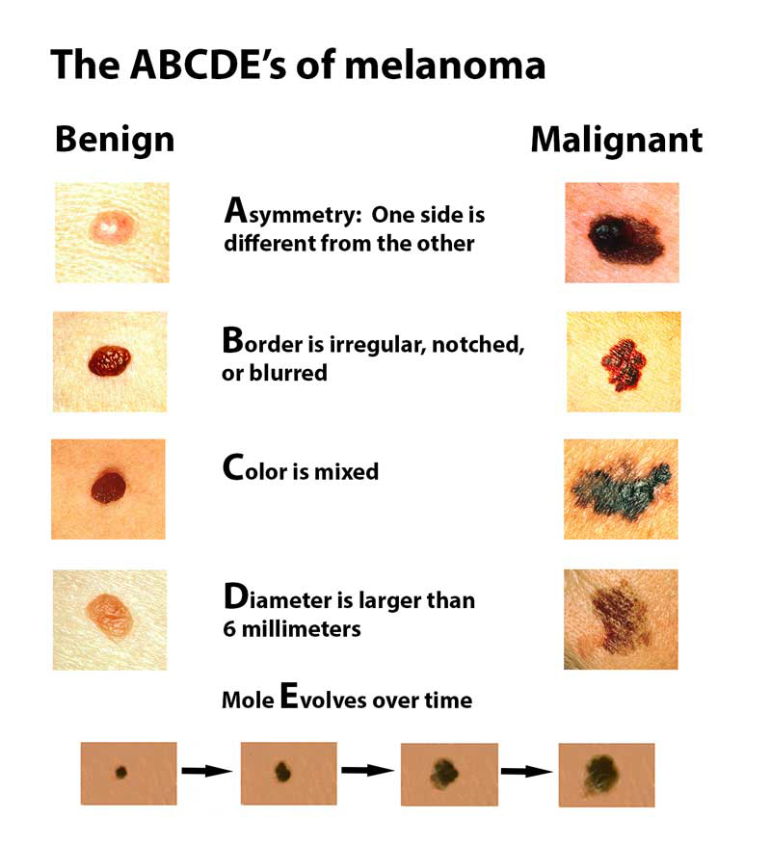

Figure 1. Melanoma is the deadliest form of skin cancer because it can spread so quickly. But it should be easy to track. It can develop from an existing mole or appear on unmarked skin. Other types of melanoma can start in a place that you might not think to look, like under fingernails, toenails and inside the eye (which is one reason that you should wear properly treated sunglasses when you’re outdoors). Use the ABCDEs to recognize the changes or characteristics of moles that may indicate melanoma.
Source: Melanoma Research Foundation, “The ABCDEs of Melanoma,” July 2017

[Disclaimer]
The information and materials included in MetLife’s Health and Wellness Information Library, including all toolkits, modules, template communications, text, charts, graphics and other materials, (collectively, the “Content”) are intended to provide general guidance on health and wellness matters and are not, and should not be relied on as, medical advice. While the Content is based on resources that MetLife believes to be well-documented, MetLife is not responsible for the accuracy of the Content, and you rely on the Content at your own risk. Each person’s condition and health circumstances are unique, and therefore the Content may not apply to you. The Content is not a substitute for professional medical advice. You should always consult your licensed health care professional for the diagnosis and treatment of any medical condition and before starting or changing your health regimen, including seeking advice regarding what drugs, diet, exercise routines, physical activities or procedures are appropriate for your particular condition and circumstances.
© 2017 METLIFE, INC.

Week 4

Subject: Get moving to prevent colon cancer

Colon cancer (or colorectal cancer) is one of the top five causes of cancer-related deaths worldwide. Yes, family history can play a role in colon cancer, but so can lifestyle changes.¹
A sedentary lifestyle is a risk factor for colon cancer.¹ If your job requires a lot of sitting (at your desk and in meetings), make it a point to get up at least once an hour and move for ten minutes.¹ Walk around your floor, the building, a flight of stairs.¹ Take it slow if you don’t have a regular exercise routine, then see if you can walk a little faster or farther.¹
A general recommendation for healthy, moderate exercise is at least 30 minutes of aerobic exercise each day, at least five days a week. Can’t fit in 30 minutes at one time? Three 10-minute blocks of exercise over the course of the day are just as good.²
Obesity is also a contributing factor to colon cancer, so moving more will help you lose weight.³ But, with colon cancer, it’s also the type of food you eat that matters.³ In other words, it’s not just about reducing your calories to lose weight.³
The World Health Organization’s International Agency for Research on Cancer released a report that recommends reducing your consumption of red meat and processed meat (which generally means meat that has been salted, cured, fermented or smoked to enhance flavor or improve the preservation of the meat). Based on these recommendations, try to eat the following foods in moderation:
- Bacon
- Sausage
- Hot dogs
- Ham
- Corned beef
- Biltong or beef jerky
- Canned meat
Also, try to limit your consumption of red meat to less than 18 ounces per week.³ There is strong but limited evidence linking the consumption of red meat to colon cancer.³
[Disclaimer]
The information and materials included in MetLife’s Health and Wellness Information Library, including all toolkits, modules, template communications, text, charts, graphics and other materials, (collectively, the “Content”) are intended to provide general guidance on health and wellness matters and are not, and should not be relied on as, medical advice. While the Content is based on resources that MetLife believes to be well-documented, MetLife is not responsible for the accuracy of the Content, and you rely on the Content at your own risk. Each person’s condition and health circumstances are unique, and therefore the Content may not apply to you. The Content is not a substitute for professional medical advice. You should always consult your licensed health care professional for the diagnosis and treatment of any medical condition and before starting or changing your health regimen, including seeking advice regarding what drugs, diet, exercise routines, physical activities or procedures are appropriate for your particular condition and circumstances.
© 2017 METLIFE, INC.

https://www.cdc.gov/cancer/breast/basic_info/prevention.htm
https://www.uspreventiveservicestaskforce.org/Page/Document/RecommendationStatementFinal/breast-cancer-screening1
https://www.cancer.org/cancer/breast-cancer/understanding-a-breast-cancer-diagnosis/breast-cancer-survival-rates.html2
https://www.menshealth.com/health/skin-cancer-facts-that-are-actually-wrong/slide/2
http://www.smh.com.au/lifestyle/life/top-five-myths-about-skin-cancer-20141015-116ay0.html
https://www.asds.net/SkinCancerInformation.aspx
https://www.cancer.gov/types/skin/anyone-can-get-skin-cancer
https://www.uspreventiveservicestaskforce.org/Home/GetFileByID/2778
https://www.cancer.gov/types/skin/hp/skin-treatment-pdq#section/all
1 https://www.uptodate.com/contents/colon-and-rectal-cancer-screening-beyond-the-basics
http://www.heart.org/HEARTORG/HealthyLiving/PhysicalActivity/FitnessBasics/American-Heart-Association-Recommendations-for-Physical-Activity-in-Adults_UCM_307976_Article.jsp#.WjR0ZlWnHIU
http://www.iarc.fr/en/media-centre/iarcnews/pdf/Monographs-Q&A_Vol114.pdf

